Kem Chan
CS 405 – Secure Coding
Sept 8, 2026
Assignment 1 – Numeric Overflow

Screenshot of code
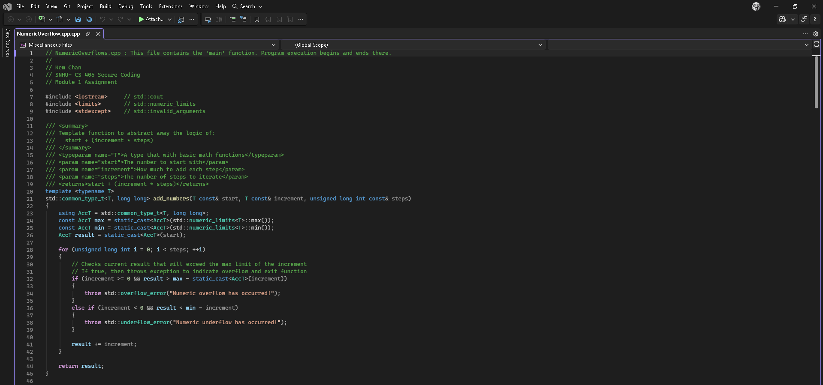
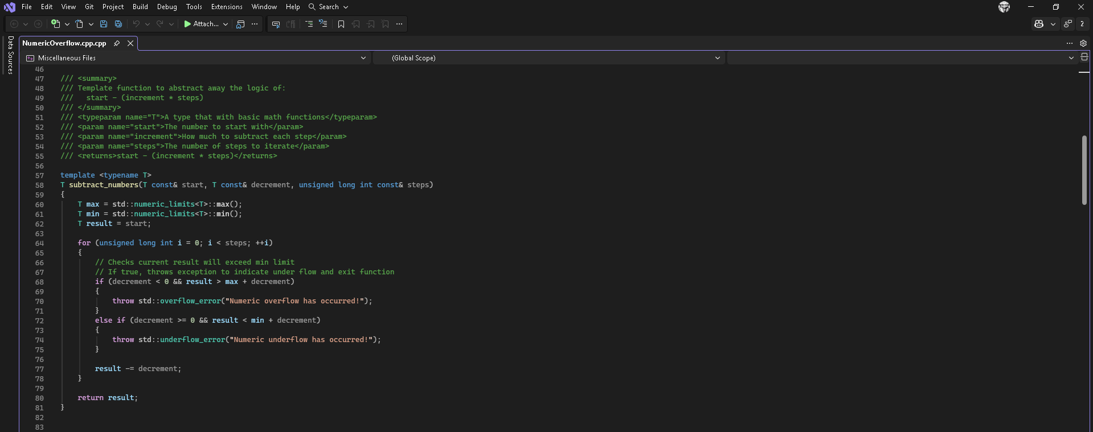
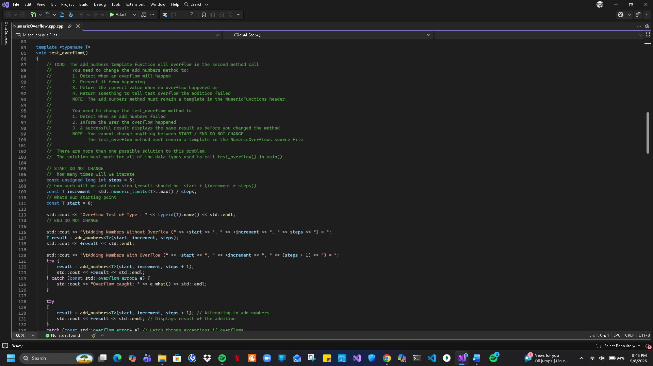
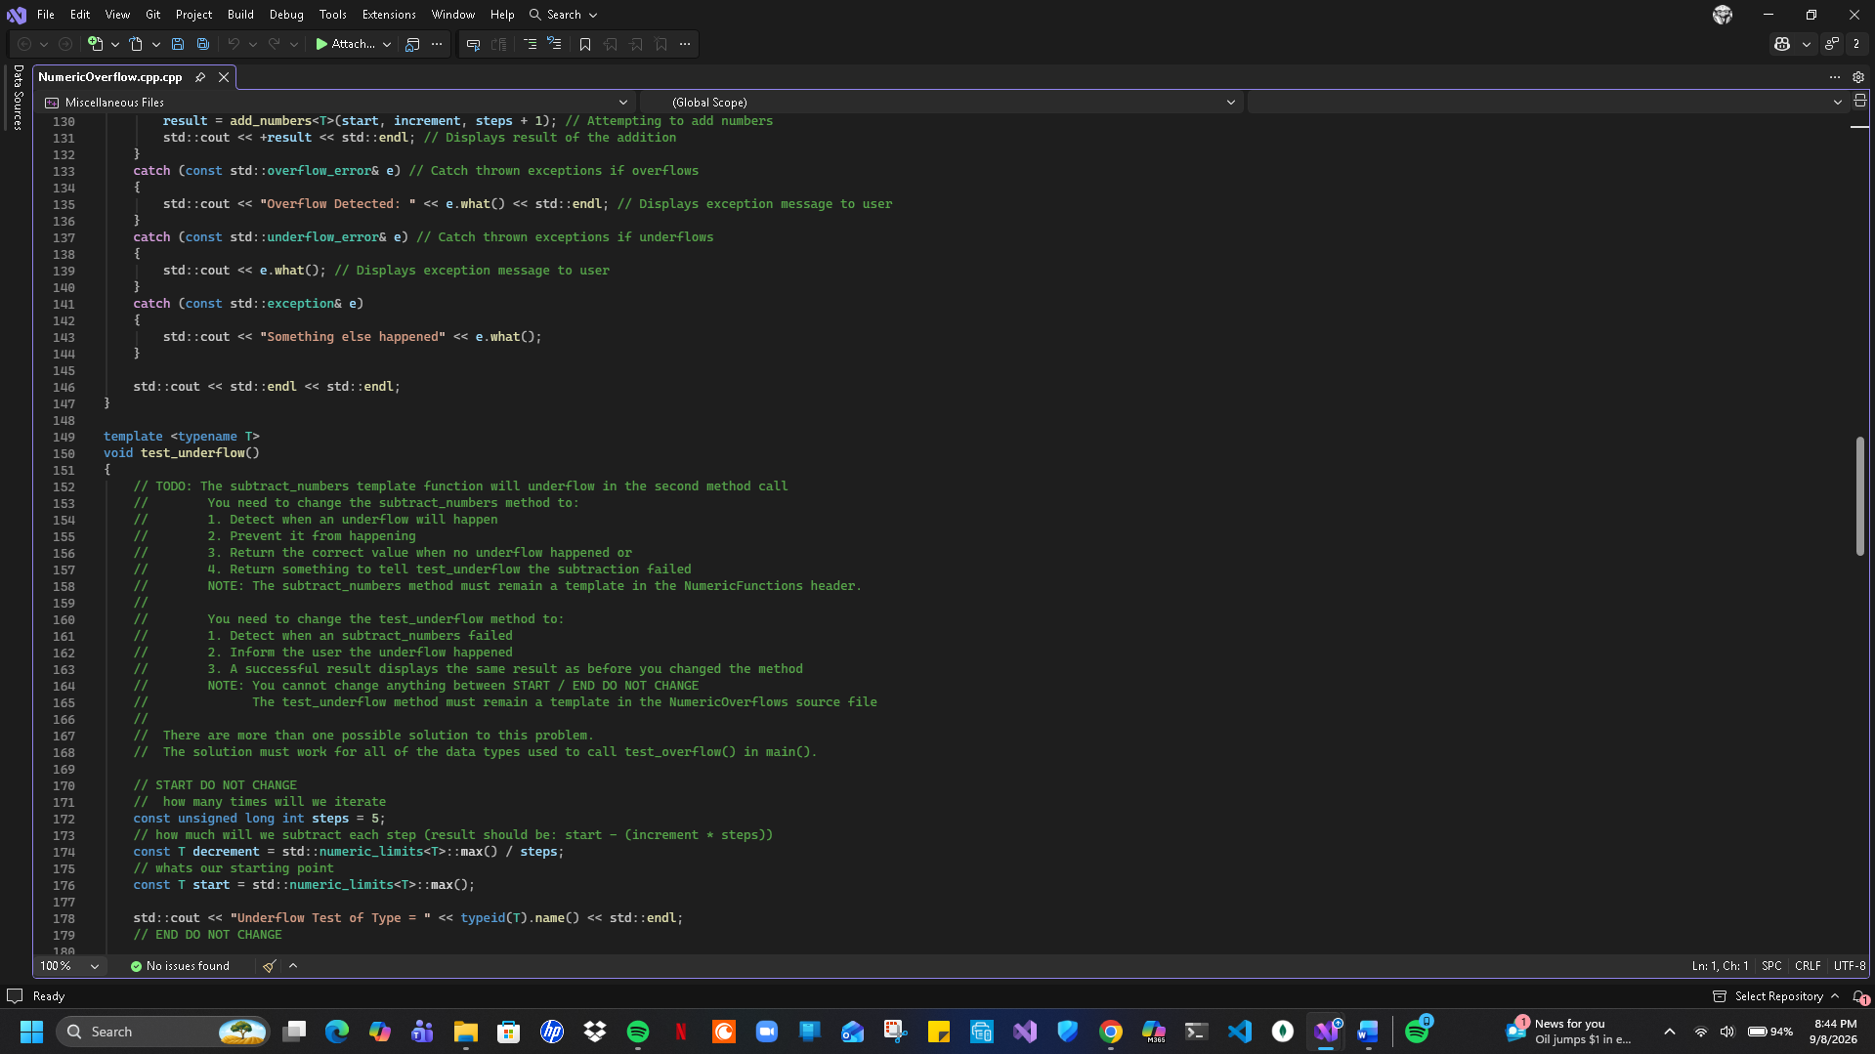
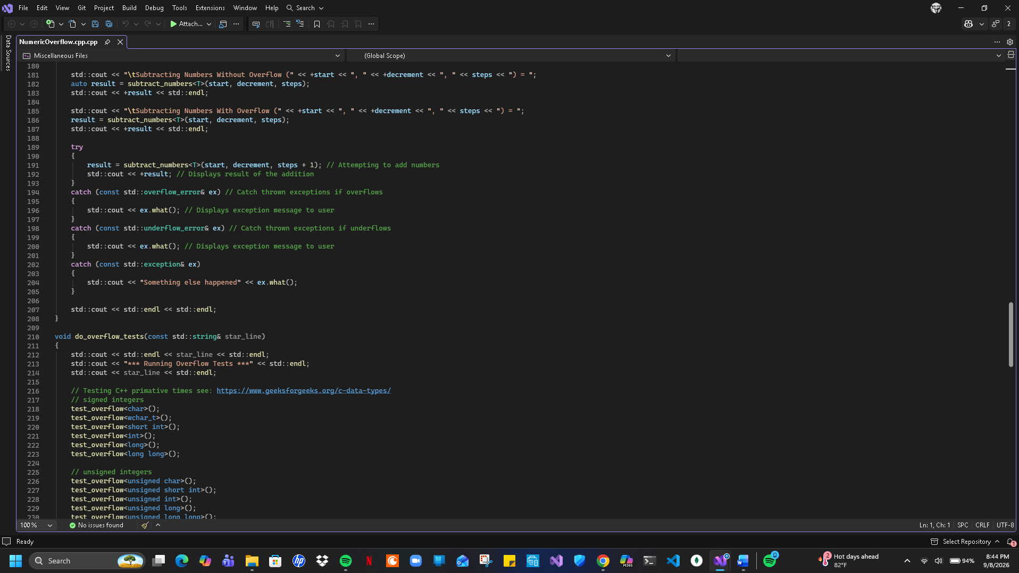
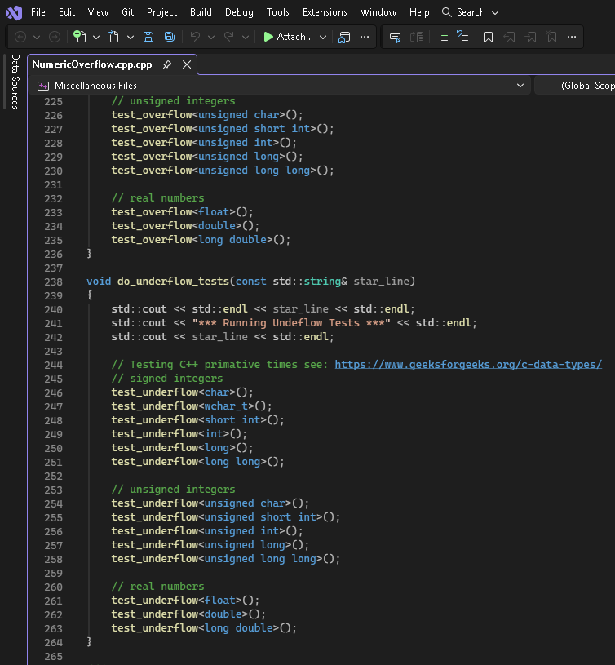
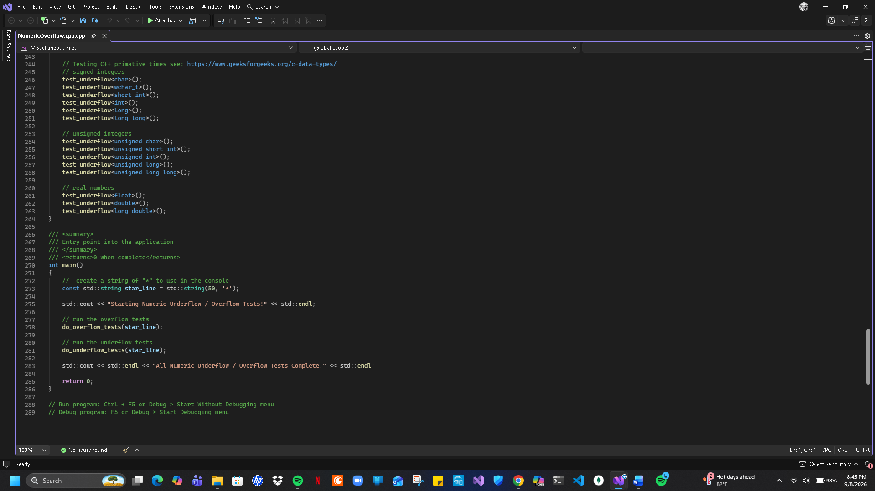

Screenshot of results
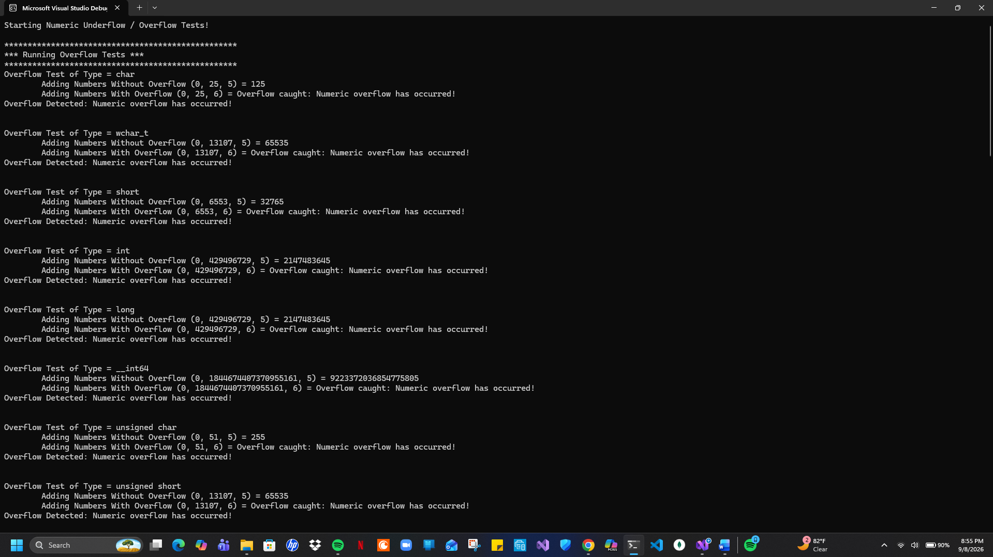
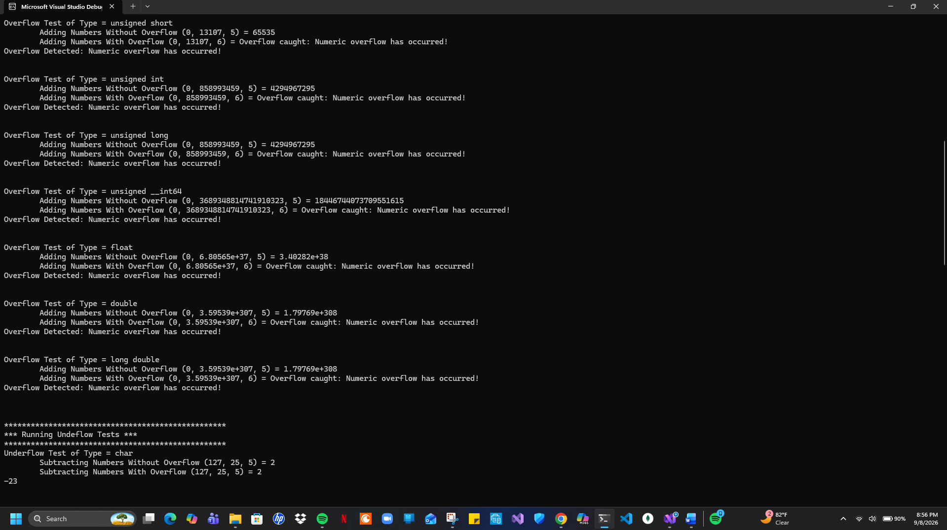
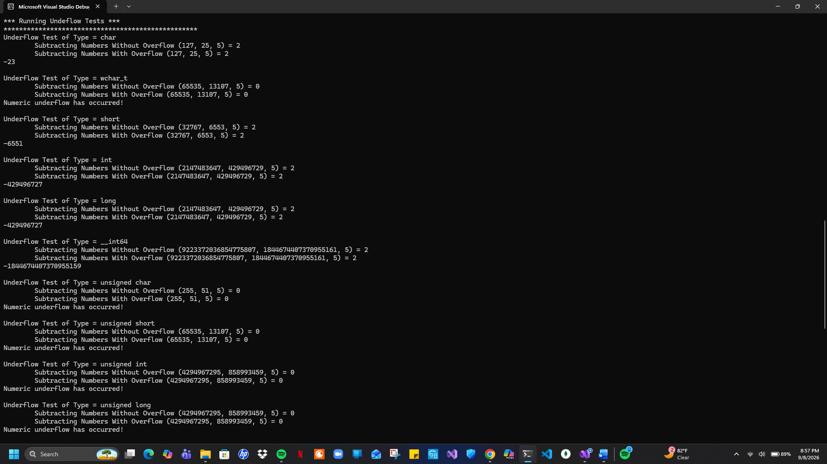
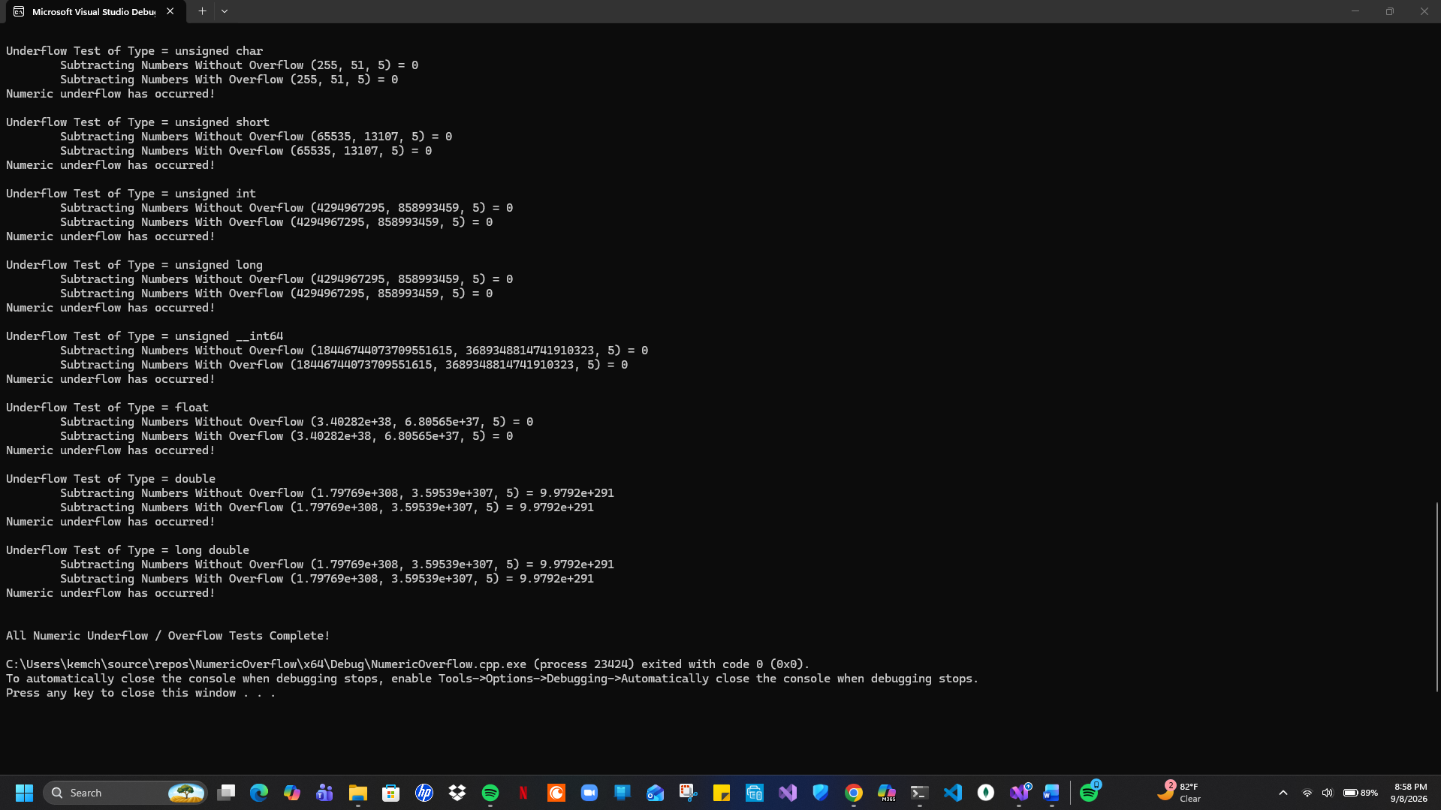
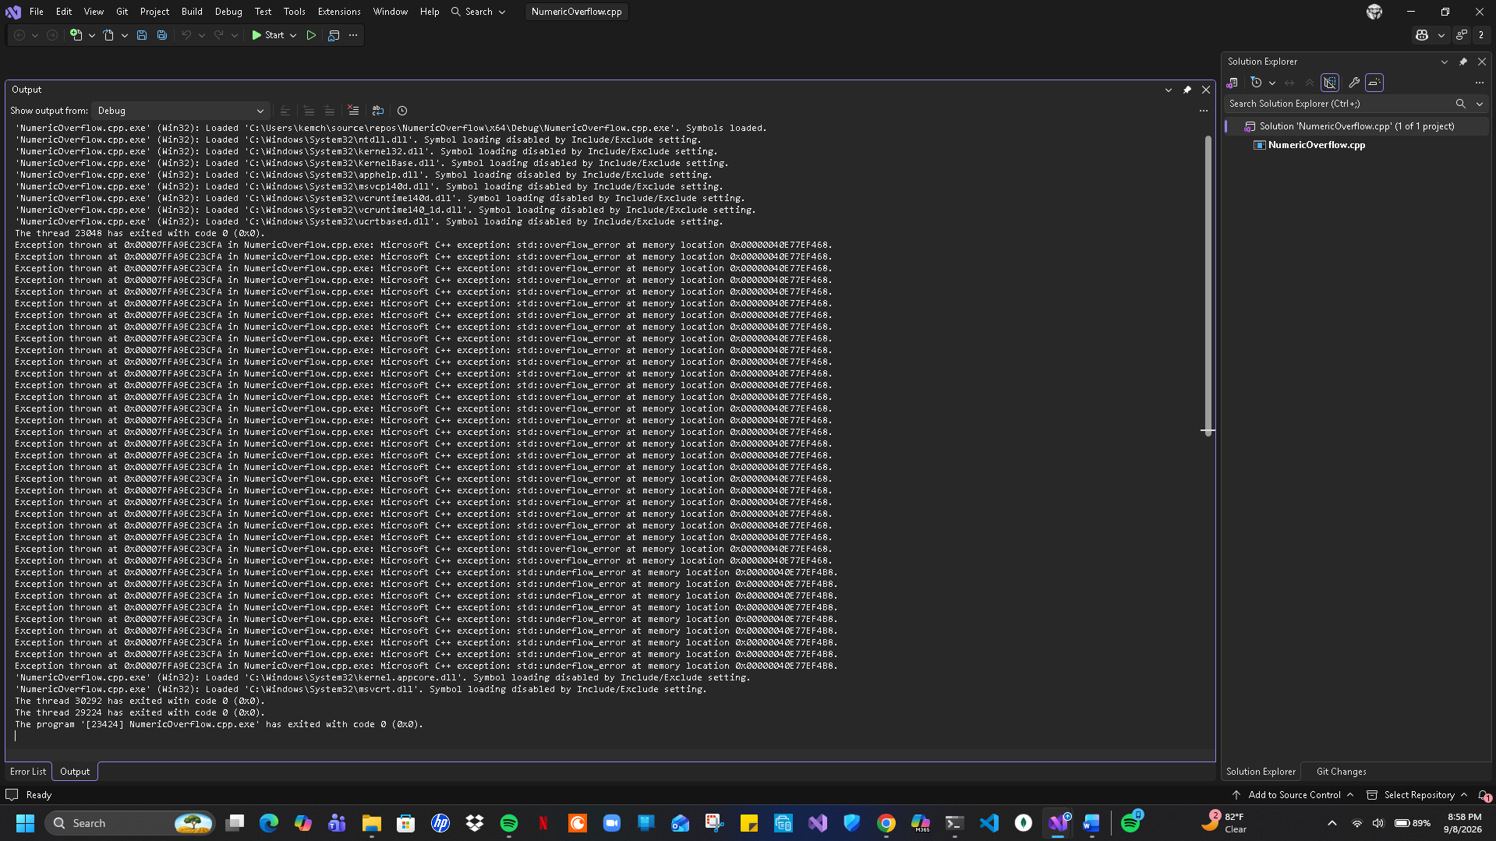
Summary
Going into this assignment helps to lay out the limits of the program and comprehend what was needed to make sure the system will not overload. The first thing to input was a way to test underflow as well as overflow functions and be able to produce a result whether it is a success or failure of doing addition or subtraction that would be called on. The result from these functions would produce either a true or false read from the numeric results of the function.

